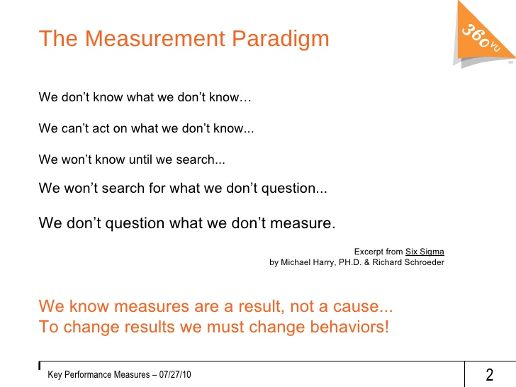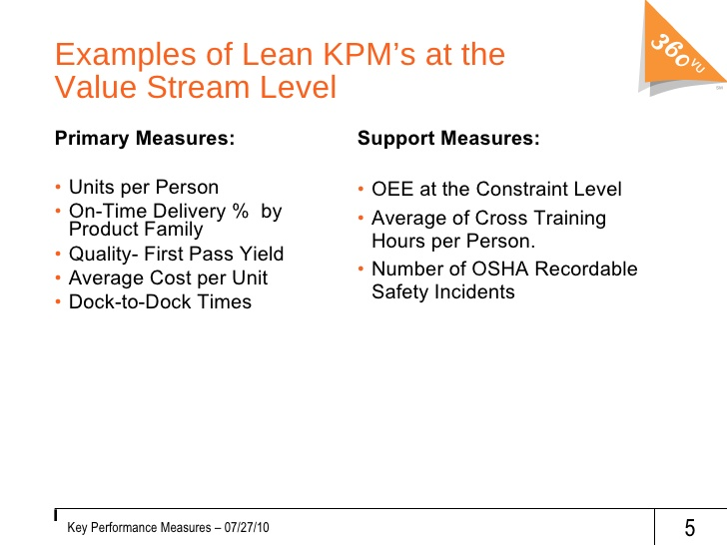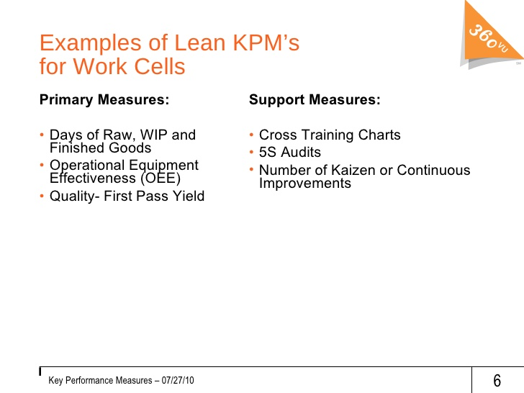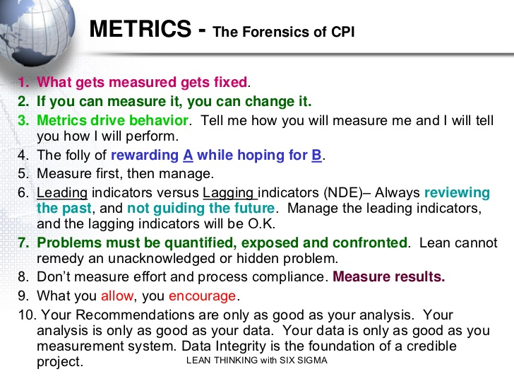

PROBLEM / CURRENT STATE – Most business leaders see Lean/CI as tools to be applied within the current “management system”. That makes it hard to “self-sustain” and derive the full benefits.
TARGET / DESIRED STATE – Business Leaders need to see Lean/CI as a “management system”. A MS that drives never-ending improvement of the way work is done (waste reduction) and never-ending refinement of the MS itself. That’s what a “culture of CI” is.
SOLUTION – Link traditional financial metrics to Lean/CI objectives, methods, and metrics to allow business leaders to “see” / understand the value of Lean/CI practices. Key to influencing business and financial leaders to support CI commitment (training and strategic application of practices).
Business / Financial Metric | Operational Description | Lean Methodology | Lean Metric
Sales Growth | Quick Response | Reduced set-up times (SMED) | Set up times
What does the customer value, | Small quantity orders | Standardized Work | Order to ship times
what is the customer willing to | Customized products | Repeatable processes | Throughput times
pay for? | Consistent quality, timing | 5S, Kanbans, VSM | On time delivery
 |  |  | % of tasks documented
Improved Cash Flow | Reduced inventories | Predictable product flow | Inventory turns
Cash moving through the | Use of non-productive assets | Single-piece flow | Increased capacity
Enterprise, not locked up in | Elimination of non-productive | 5S, Kanbans, Takt time, VSM | Decreased downtime
assets | assets | TPM | OEE (overall equip efficiency)
Lower Product Costs | Reduced waste in multiple forms | Root cause problem solving | % or # problems solved
Decreased product costs at any | Materials | Standard work | % of defects / errors
Point in the process can increase | Reduced defects | Labor cost reductions (all costs) | Cost per unit
Profit margins |  | Reduced rework
Improved ROI / ROE
How to get greater returns lower
While reducing investment /
Equity? Use profits for growth.

